Pliocene Mollusk Communities and the Neogene Atlas

by Andrielle Swaby

Last updated June 29, 2018

Introduction

In this activity, we will visit mollusk communities across the Pliocene coastline of North America, from Virginia to Florida. During the exercise, we will learn about species diversity and distribution in Pliocene coastal environments, and use that information to discover what the paleoenvironment was like.

We will use data tables and life history information found on the Neogene Atlas of Ancient Life (www.neogeneatlas.net). Bulk shell samples from different locations have been collected and itemized on the Atlas, and you'll use the information found there to compare different mollusk communities.

The diagram on the following page illustrates which formations are found in the same unit of time. Older formations are at the bottom of the figure and younger ones are closer to the top. Time periods are listed on the left-hand axis. For the purposes of this activity, units of time that contain multiple formations will be called "time slices." These time slices travel horizontally across the diagram, like layers on a cake. We will be comparing communities that occur in the same time slice, but different geographic areas.

Why do you think it might be important to compare samples across the same restricted time slice, instead of just any samples in the Upper Pliocene (or the entire Pliocene)?

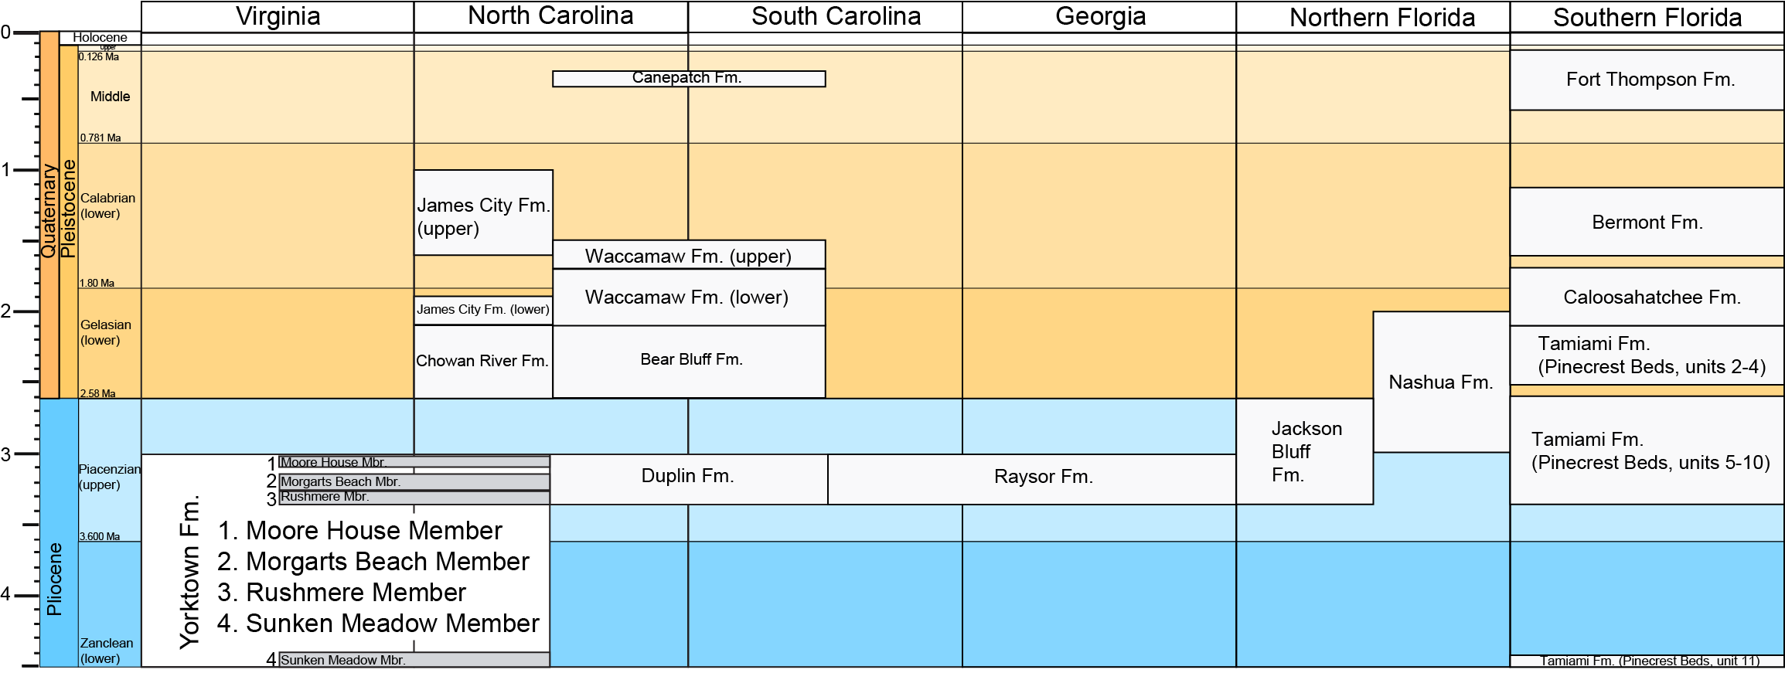

Part I
The Yorktown Formation

To compare the diversity of mollusk communities, we'll need to collect some information from each sample. Look at the Faunal Lists page on the Neogene Atlas (http://neogeneatlas.net/faunallists/) and locate sample 94LCA-CB-16. Record the following information:

State
Formation
Member or Group
Total Number of Bivalve Taxa
Total Number of Gastropod Taxa

Find out which families of bivalves make up 5% or more of the sample by clicking on the taxon names. Record the name of the family and the percentage of the sample.

Find out which families of gastropods make up 2% or more of the sample by clicking on the taxon names. Record the name of the family and the percentage of the sample.

Click on the name of each family to learn more about its ecology, life history, and life habits.
Based on the life habits of the major mollusk groups in this community, what do you think the paleoenvironment was like at this location?

Go back to the Faunal Lists page. Are any of the other Yorktown Members in the same time slice as your first sample?

Let's collect the same data from another Yorktown sample in this time slice.

Sample Number
State
Formation
Member or Group
Total Number of Bivalve Taxa
Total Number of Gastropod Taxa

Families of bivalves making up more than 5% of the sample:

Families of gastropods making up more than 2% of the sample.

Using a bar graph, graph the percent abundance of these taxa across the two samples you just surveyed.

What similarities and differences do you notice across these two Yorktown samples? Why do you think they are similar or different?

Based on what you know about the life habits of the major mollusk groups in your samples, draw a reconstruction of the paleoenvironment in the Yorktown during this time period.

Part II
Moving Down the Coast

We’ll now compare the community from the Yorktown Formation in Virginia to locations in other states. Which other formations on the Faunal Lists page are found in the same time slice as the formations you just looked at?

Gather the same data as you gathered in Part I from two Georgia samples and four Florida samples.

Using a bar graph, graph the percent abundance of the major bivalve and gastropod taxa across the seven samples you just surveyed.

What similarities and differences do you notice across the samples? How do they compare to the Yorktown communities?

Based on what you know about the life habits of the major mollusk groups in your samples, what do you think the paleoenvironment was like in the Duplin and Tamiami Formations? Draw reconstructions of the paleoenvironment in Georgia and Florida during this time period.

Part III
Understanding Paleoecology

How did the diversity of your samples change as you travelled along the coast of North America? Look both at the total number of bivalve vs. gastropod taxa in each community, as well as the mollusk families that made up the largest proportions of the samples.

Why do you think the diversity of the communities changed in the way it did?
Hint: think about the temperature of the environment.

Did you notice anything about the distribution of bivalves versus gastropods?

Why do you think this occurred?

We looked at communities that occurred at the same time but in different geographic locations. What if we were looking at a community in the same geographic location, but over different times? What are some ways that community structure could change, and what are some environmental factors that could cause those changes?

