Marine Ecosystems and the Cretaceous Western Interior Seaway Lesson Plan
NAME:
DATE:

Defining Success | OBJECTIVE. (Include standards.)
Students will be able to investigate the food web of the Cretaceous Western Interior Seaway.
Students will be able to compare and contrast land and ocean ecosystems.

 | Next Gen Standards: MS-LS2-2, MS-LS2-5, MS-ESS1-4
 | ASSESSMENT. | KEY POINTS.
 | How will we know if students are successful?  - Students will have completed a food web and have the ability to trace the flow of energy from producer to consumer.  - Marine food webs rely on phytoplankton as their primary producers, and support more kinds of predatory animals than terrestrial ecosystems do. They are similar in that their energy all comes from the Sun. | What does the teacher need to know to teach this lesson?  - Food web lessons that have been discussed in classes prior to this can be applied to ancient ecosystems as well as modern ones.  - For around 50 million years (113-66 million years ago) in the Cretaceous period, the center of North America was covered by a shallow, warm-water ocean that was home to the large marine reptiles of the Mesozoic.  - At first students will assume that land-based producers are the same as marine producers. This isn’t correct, so expect to be correcting this (there are slides in the associated PowerPoint for this).

Lesson Cycle | OPENING/DO NOW. | MATERIALS.
 | Students will independently draw an example of a food web they are familiar with and label one consumer and two producers. Producers are organisms that provide energy to the ecosystem such as plants. Consumers are organisms that consumer energy, animals are consumers. Food webs show the flow of energy throughout an ecosystem, as opposed to a food chain which shows a linear flow.  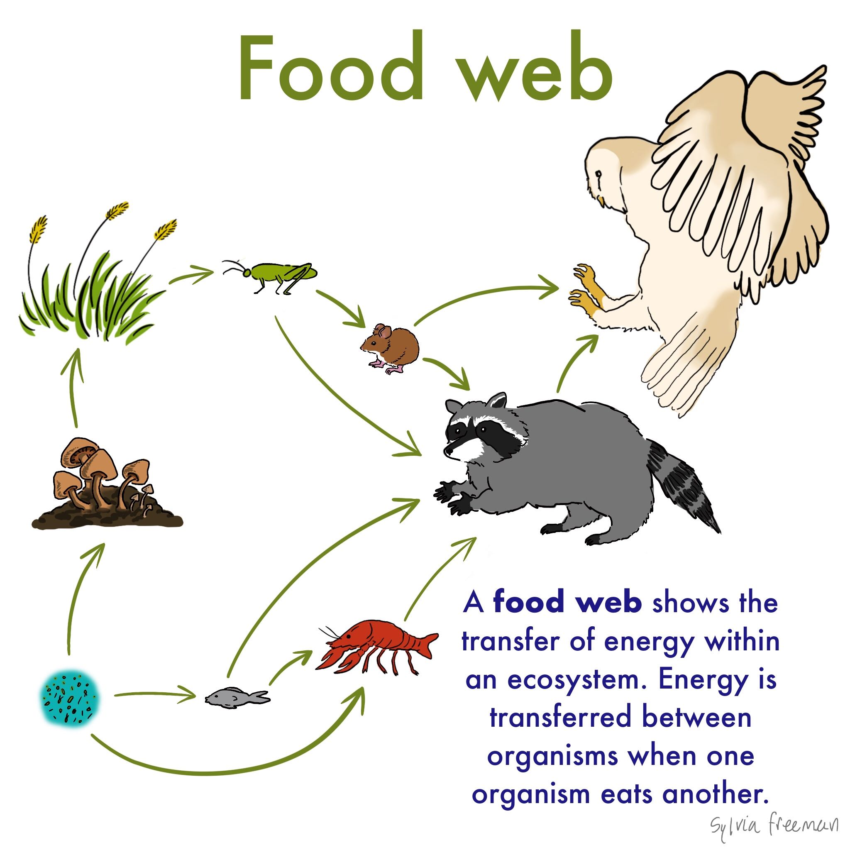 | Worksheet  Power Point  Pointer
 | INTRODUCTION OF NEW MATERIAL.
Students will be split up across the room. If they believe that the main producers in marine systems are plants, they will go to one side of the room, if they believe the producers are phytoplankton they go to the other. They should be prepared to justify their response.
After this exercise they will be shown that the correct answer isn’t a plant like it is on land. They will be shown that ocean ecosystems are largely based on phytoplankton.

The associated PowerPoint will go through some of the important animals in the Western Interior Seaway, and show students what each of them eat and how they live.

 | GUIDED PRACTICE.
 | Based on this knowledge students will fill in the food web in the worksheet by drawing arrows from food to consumer.
 | INDEPENDENT PRACTICE.
Students will compare their food web with one made by a classmate to see the differences. Because food webs are complex and dynamic there is no single correct answer. this is especially true of extinct ecosystems because unless we find fossils of one species in the stomach of another, we have no way of knowing for sure that one species ate another.

Students will find their favorite animal in the food web and follow the energy up to it from the single-celled producers to see where their chosen animal falls.

 | CLOSING.
 | Students will finish by comparing marine and terrestrial ecosystems once again using the knowledge gained from this activity.

