Name Date

Marine Ecosystems and the Cretaceous Western Interior Seaway

Draw your favorite ecosystem! Make sure to include and label at least 1 producer and 2 consumers.

Ocean ecosystems are incredibly important to how the Earth functions, but they are different than land ecosystems in many ways. Today we’re going to be talking about how ocean ecosystems work with examples from the ancient past.

- Now think about the ocean. What might be the primary producers there? Are they the same as in ecosystems on land? What about primary consumers? Talk about it with the person next to you and be ready to share with the class.

The Western Interior Seaway was home to many animals that aren’t around today such as giant marine reptiles like mosasaurs and plesiosaurs, and large aquatic birds like Hesperornis. By learning about animals that aren’t around anymore, we can learn more about how the animals we see today work in their environments.

Ocean ecosystems have a lot of “niche partitioning” where animals that are the same shape do different things in their environment. A good example is how young fish eat different food than adult fish. Because they eat different food, there is more food to go around.

- Here are some animals that lived in the Western Interior Seaway. Their sizes are proportional (except the single-celled organism). Draw arrows from food to consumer.
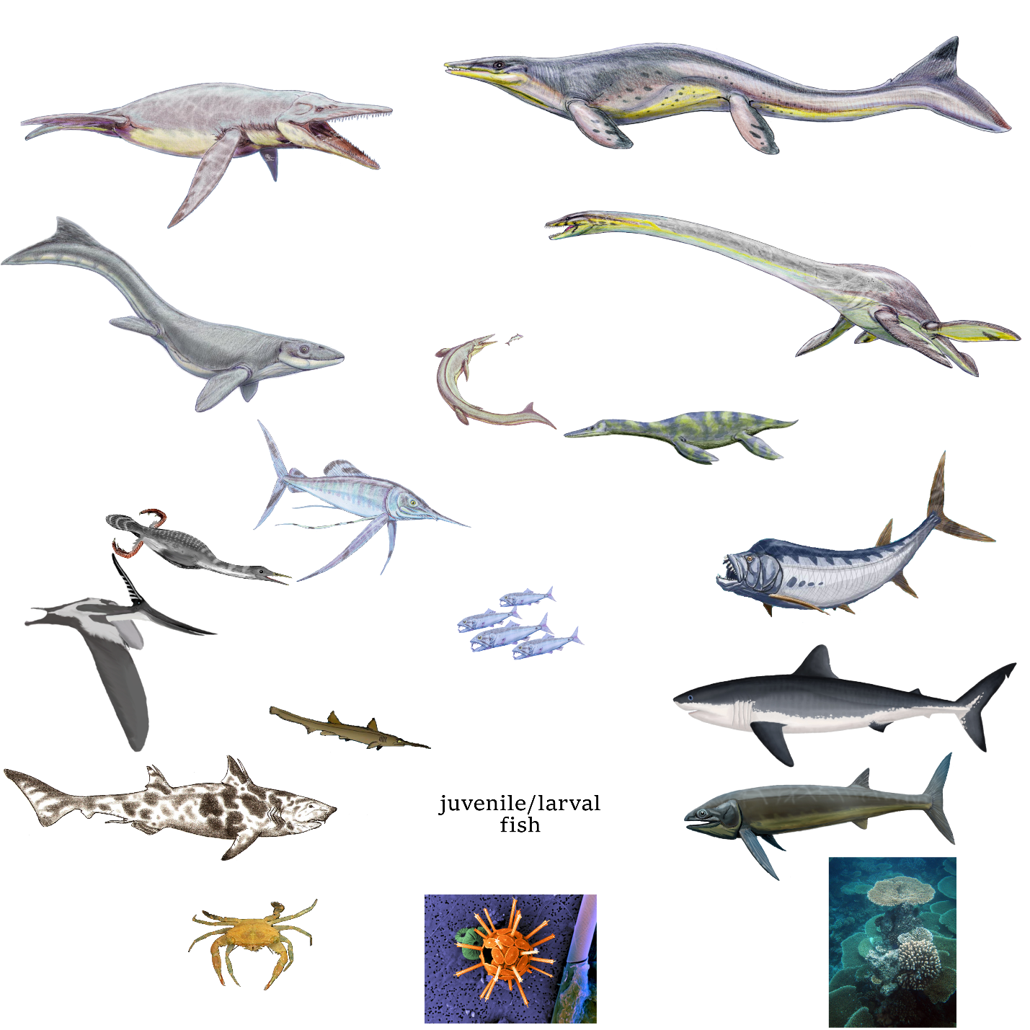

- Now compare your food web to one of your classmates’. How does yours look compared to theirs?

- What’s your favorite animal in this food web? Follow the energy from the bottom of the food web to it. How many steps does it take to get there?

- After going through this ocean food web, how is it different than food webs on land? Are there more predators on land or in the ocean?

