Name: Date:
Stratigraphic Evidence For The Cretaceous Western Interior Seaway
Goals: During this lab you will learn how to interpret evidence from geologic maps and use it to reconstruct a feature from Earth’s geologic past.
The Western Interior Seaway covered what is now the American Great Plains during most of the Cretaceous Period, from 113-66 Ma. But how do we know? Using geologic maps, we can infer which states contain sedimentary units from the Western Interior Seaway, and we can even approximate the boundaries of the seaway, which is what you’ll be doing today.
To Do:
https://ngmdb.usgs.gov/mapview/
The link above goes to comprehensive USGS map of the United States. Your job is to mark two approximate coastline boundaries of the Western Interior Seaway on the map below. One set of boundaries will be for during the Maastrichtian (the last stage of the Cretaceous) and one for the Cenomanian (an earlier stage). Here are some things to keep in mind; What letter symbolizes the Cretaceous? Are all Cretaceous deposits from the Western Interior Seaway? How can you tell terrestrial deposits from marine ones? Surficial units typically continue in the subsurface! (check out this link for an example of a good cross-section displaying this: https://ngmdb.usgs.gov/ngm-bin/pdp/zui_viewer.pl?id=13055) Don’t be afraid to ask for help on determining the depositional environment of a formation.
The table on the next page contains the names of all formations known to be associated with the Western Interior Seaway. If you are unsure about if a unit on the map is associated, try to find it within the table.

Formation | Age | Formation | Age | Formation | Age
Corsicana | Maastrichtian | Brownstone | Santonian/Campanian | Eagle Mountain SS | Cenomanian
Escondido | Maastrichtian | Eagle | Santonian/Campanian | Woodbine | Cenomanian
Fox Hills SS | Maastrichtian | Everts | Santonian/Campanian | Dakota SS | Albian/Cenomanian
Hell Creek | Maastrichtian | Point Lookout | Santonian/Campanian | Mowry Sh | Albian/Cenomanian
Kemp Clay | Maastrichtian | Telegraph Creek | Santonian/Campanian | Purgatoire | Albian/Cenomanian
Olmos | Maastrichtian | Virgelle | Santonian/Campanian | Washita Grp | Albian/Cenomanian
Trinidad | Maastrichtian | Blossom SS | Santonian | Caddo | Albian
Vermejo | Maastrichtian | Austin Sh | Coniacian/Campanian | Edwards Lmst | Albian
Aguja | Campanian/Maastrichtian | Bacon Ridge SS | Coniacian/Campanian | Fredricksburg Grp | Albian
Bearpaw Sh | Campanian/Maastrichtian | Cody Sh | Coniacian/Campanian | Kiamichi | Albian
Horsethief | Campanian/Maastrichtian | Niobrara Sh | Coniacian/Campanian | Newcastle SS | Albian
Lennep | Campanian/Maastrichtian | Pen | Coniacian/Campanian | Skull Creek Sh | Albian
Lewis Sh | Campanian/Maastrichtian | Blind Bull | Coniacian/Santonian | Thermopolis Sh | Albian
Mesaverde | Campanian/Maastrichtian | Bonham | Coniacian/Santonian | Weno | Albian
Nacatoch SS | Campanian/Maastrichtian | Hillard Sh | Coniacian/Santonian
Navarro Grp | Campanian/Maastrichtian | Tokio | Coniacian | SS = Sandstone | Sh = Shale
Pictured Cliffs | Campanian/Maastrichtian | Baxter Sh | Turonian/Campanian | Grp = Group | Lmst = Limestone
Pierre Sh | Campanian/Maastrichtian | Henefer | Turonian/Campanian
San Miguel | Campanian/Maastrichtian | Straight Cliffs | Turonian/Campanian
Anacacho Lmst | Campanian | Gallup SS | Turonian/Coniacian
Blair | Campanian | Atarque SS | Turonian
Castlegate | Campanian | Moreno Hill | Turonian
Claggett | Campanian | Tres Hermanos | Turonian | 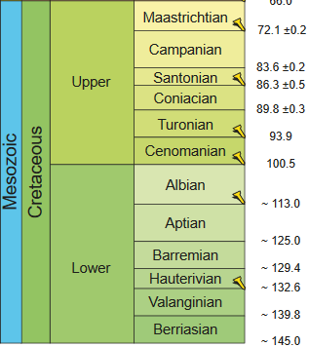
Cliff House | Campanian | Colorado Grp | Cenomanian/Campanian
Elk Basin SS | Campanian | Mancos | Cenomanian/Campanian
Gober Sh | Campanian | Ojinaga | Cenomanian/Campanian
Iles | Campanian | Marias River Sh | Cenomanian/Santonian
Marlbrook | Campanian | Benton Grp | Cenomanian/Turonian
Menefee | Campanian | Boquillas | Cenomanian/Turonian
Mount Garfield | Campanian | Carlile Sh | Cenomanian/Turonian
Ozan | Campanian | Eagle Ford | Cenomanian/Turonian
Pecan Gap | Campanian | Frontier | Cenomanian/Turonian
Roxton Lmst | Campanian | Graneros Sh | Cenomanian/Turonian
Sego SS | Campanian | Greenhorn | Cenomanian/Turonian
Sprinkle | Campanian | Tropic Sh | Cenomanian/Turonian
Talyor Grp | Campanian | Belle Fourche | Cenomanian
Wolfe City | Campanian | Buda Lmst | Cenomanian
Montana Grp | Santonian/Maastrichtian | Del Rio Clay | Cenomanian

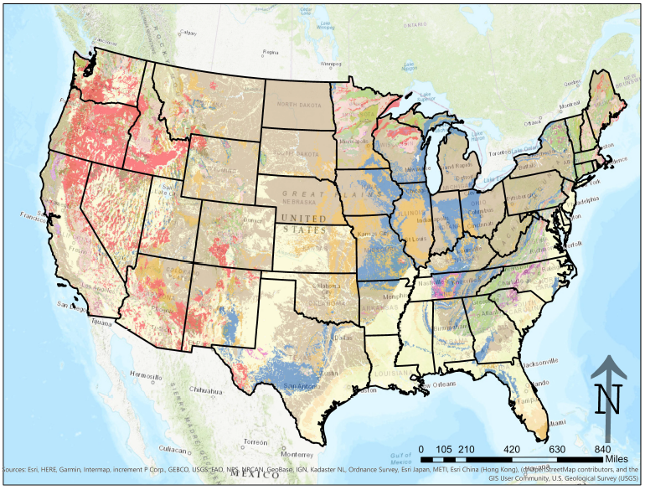

Reflection: Now that you’ve made your composite map, it’s time to reflect on how you did in drawing your boundaries on the state maps.
- South Dakota’s surficial units from the Cretaceous stop at the Missouri River. Did the Western Interior Seaway stop there as well? What evidence might support your answer?

- Some states were once completely covered in sediment from the Cretaceous. Which states? What events might have happened since the Cretaceous that might have removed (or covered) some of this material?

- Look back at the online map. Find the Nebraska/Kansas border around the 101̊ and 102̊ longitude lines (on their western side). Do the formations match up perfectly between the maps? What is the Nebraska map missing that the Kansas map has? How might this affect the boundaries you drew?

- Below is a section of a map from a renowned paleomap maker, Dr. Ron Blakey. This map is his projection of the Western Interior Seaway 75 Ma during the Cenomanian (between the two stages you drew). What kinds of geological evidence might have led Dr. Blakey to place a coastline where he did on this map?

