Name: Date:
Stratigraphic Evidence For The Cretaceous Western Interior Seaway
Goals: During this lab you will learn how to interpret evidence from geologic maps and use it to reconstruct a feature from Earth’s geologic past.
The Western Interior Seaway covered what is now the American Great Plains during most of the Cretaceous Period, from 113-66 Ma. But how do we know? Using geologic maps, we can infer which states contain sedimentary units from the Western Interior Seaway, and we can even approximate the boundaries of the seaway, which is what you’ll be doing today.
To Do: The links below go to USGS maps of states that contain deposits from the Western Interior Seaway. Your job is to find those units, then mark two approximate coastlines on each. One coastline will be for during the Maastrichtian (the last stage of the Cretaceous) and one for the Cenomanian (an earlier stage). Here are some things to keep in mind; What letter symbolizes the Cretaceous? Are all Cretaceous deposits from the Western Interior Seaway? How can you tell terrestrial deposits from marine ones? Surficial units typically continue in the subsurface! (see the Nebraska and Kansas maps and Plate 2 of the Utah map for examples). Don’t be afraid to ask for help on determining the depositional environment of a formation.
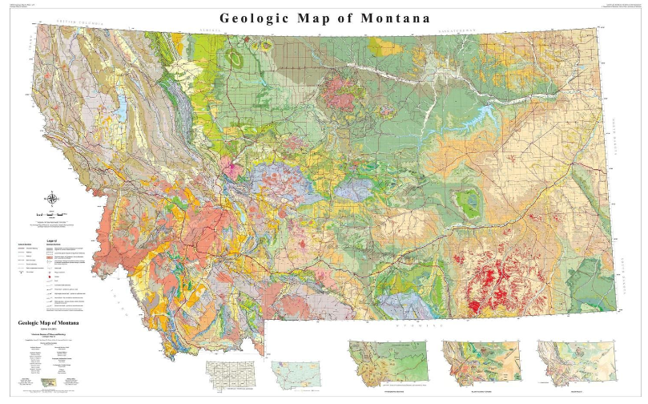
Montana: https://ngmdb.usgs.gov/Prodesc/proddesc_81651.htm

North Dakota: https://ngmdb.usgs.gov/ngm-bin/pdp/zui_viewer.pl?id=36812

Minnesota: https://ngmdb.usgs.gov/ngm-bin/pdp/zui_viewer.pl?id=36870

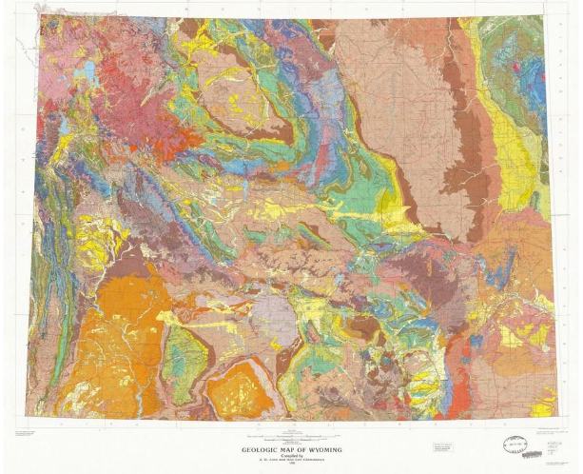
Wyoming: https://ngmdb.usgs.gov/Prodesc/proddesc_16366.htm

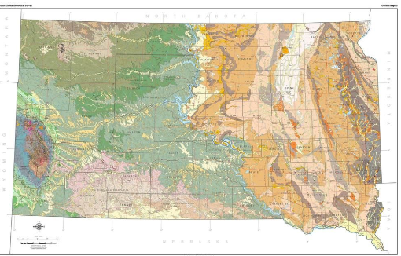
South Dakota: https://ngmdb.usgs.gov/ngm-bin/pdp/zui_viewer.pl?id=30355

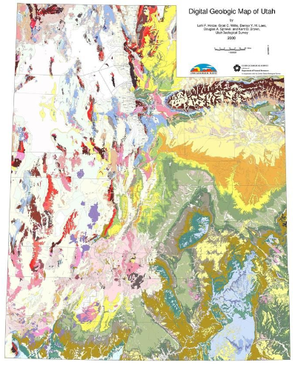
Utah: https://ngmdb.usgs.gov/Prodesc/proddesc_67350.htm

Colorado: https://ngmdb.usgs.gov/Prodesc/proddesc_68589.htm
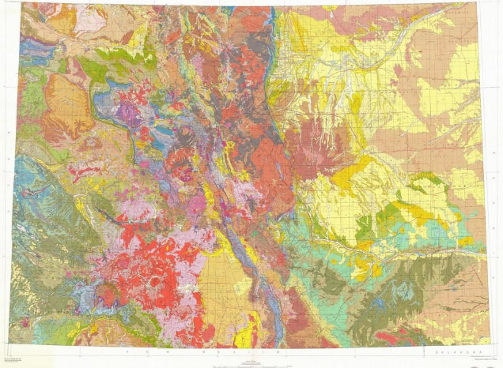

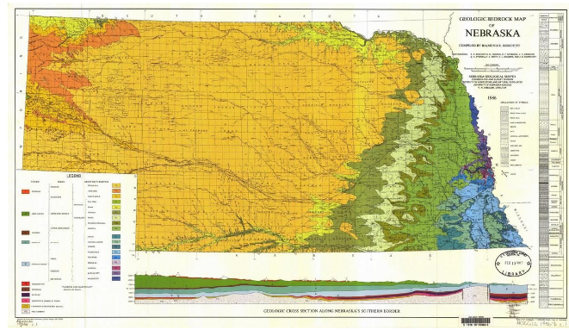
Nebraska: https://ngmdb.usgs.gov/ngm-bin/pdp/zui_viewer.pl?id=13055

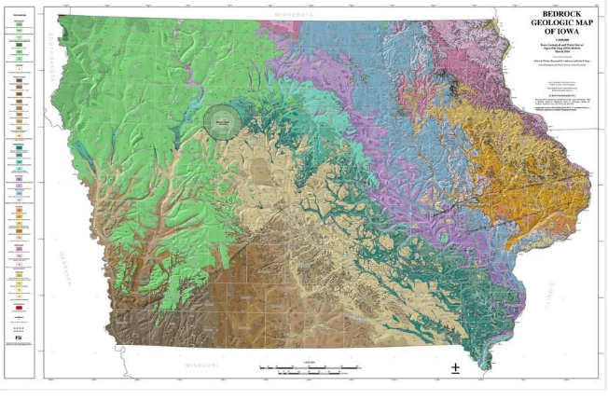
Iowa: https://ngmdb.usgs.gov/ngm-bin/pdp/zui_viewer.pl?id=36869

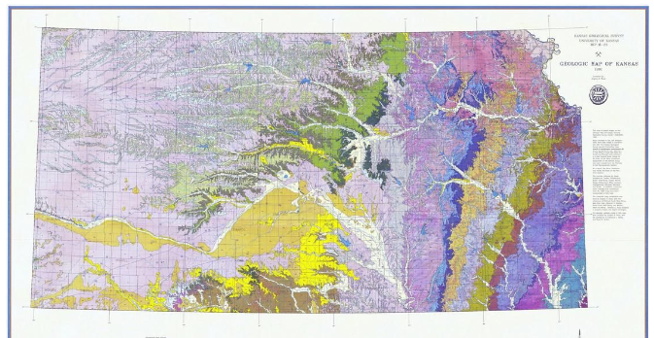
Kansas: https://ngmdb.usgs.gov/ngm-bin/pdp/zui_viewer.pl?id=7356

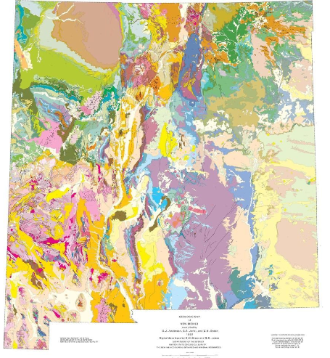
New Mexico: https://ngmdb.usgs.gov/Prodesc/proddesc_22974.htm

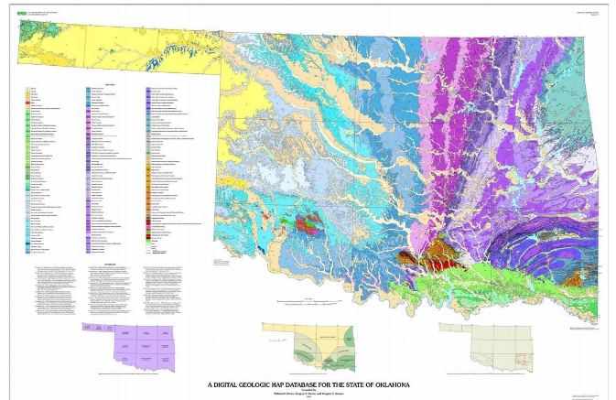
Oklahoma: https://ngmdb.usgs.gov/ngm-bin/pdp/zui_viewer.pl?id=6781

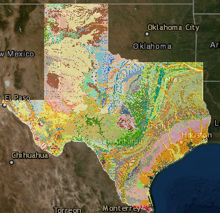
Texas: https://txpub.usgs.gov/txgeology/

This map is different than the others because Texas is so large of a state. When you click on a formation on the webmap a description and time of the unit will pop up.
Compiling Your Maps: Now that you have your approximate boundaries in these states, it’s time to compile these maps into a composite map of the Western Interior Seaway. To do this, just take the boundaries drawn on the state maps and draw them in the same approximate locations on the map on page 8. For this composite map, draw the boundaries as close to the state maps as possible. Remember to draw both of your boundaries for the two stages, Maastrichtian and Cenomanian. If the boundaries don’t match up from one state to a neighboring state, that’s alright. We’ll evaluate why they might not line up later.

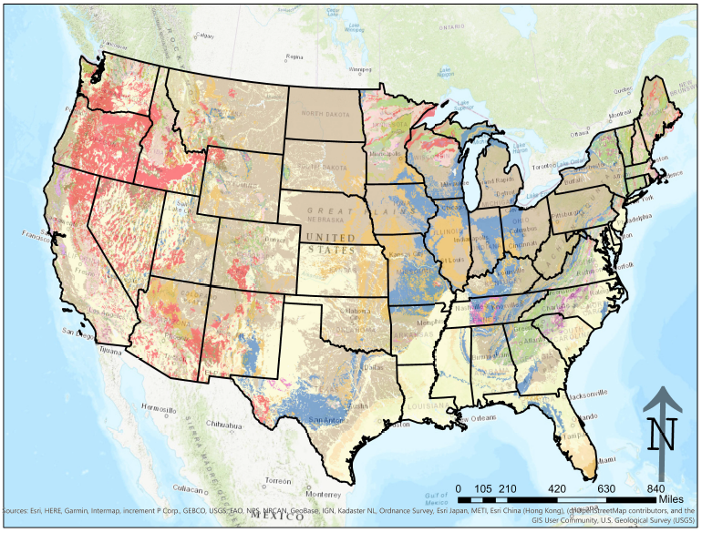

Reflection: Now that you’ve made your composite map, it’s time to reflect on how you did in drawing your boundaries on the state maps.
- Did your boundaries line up perfectly? If not, why? Should state geologic maps be considered in isolation, or do you need context from surrounding states?

- South Dakota’s surficial units from the Cretaceous stop at the Missouri River. Did the Western Interior Seaway stop there as well? What evidence might support your answer?

- Look back at the maps for Kansas and Nebraska. Look at the western-most part of their border, between the 101̊ and 102̊ longitude lines. Do the formations match up perfectly between the maps? What is the Nebraska map missing that the Kansas map has? How might this affect the boundaries you drew?

- Some states were once completely covered in sediment from the Cretaceous. Which states? What events might have happened since the Cretaceous that might have removed (or covered) some of this material?

- Below is a section of a map from a renowned paleomap maker, Dr. Ron Blakey. This map is his projection of the Western Interior Seaway 75 Ma during the Campanian (between the two stages you drew). What kinds of geological evidence might have led Dr. Blakey to place a coastline where he did on this map?

