Duplin Formation
South Caroline and
North Carolina
~3 million years old
Jackson Bluff Formation
Northern Florida Panhandle
~3 million years old
Yorktown Formation
North Carolina and Virginia
~3 million years old
Tamiami Formation
Southern Florida
~3 million years old
Location Series Maps
Name_____________________________

Species Through Time: Location Data
Group | Species | Tamiami Fm. | Jackson Bluff Fm. | Duplin Fm. | Yorktown Fm.
 |  | ~3 million y.o. | ~3 million y.o. | ~3 million y.o. | ~3 million y.o.
Gastropods | Conus adversarius | 2810 | 284
 | Conasprella marylandica | 202 | 6
 | Fusinus equalis
 | Neverita duplicata
 | Turritella subannulata
 | Xenophora floridana
Bivalves | Chesapecten jeffersonius
 | Crassostrea virginica
 | Lucina pensylvanica
 | Panchione ulocyma
 | Planicardium virginianum
Corals | Manicina areolata

Which location has the greatest diversity of species? ___________________________

In which location have the most fossils been found? ___________________________

Which five species have been found in greatest abundance overall?
1) 2) 3) 4) 5)

Put the five most common species for each location in order from most abundant to least abundant:
Tamiami
1)
2)
3)
4)
5)
Jackson Bluff
1)
2)
3)
4)
5)
Duplin
1)
2)
3)
4)
5)
Yorktown
1)
2)
3)
4)
5)

Are the most common species the same at each location? What are the similarities and differences?

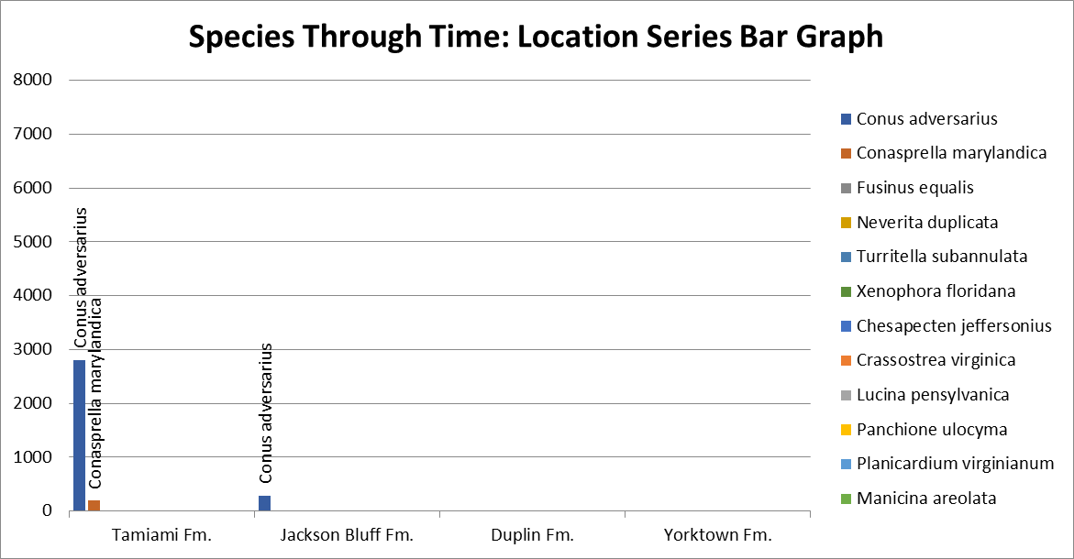
Name _____________________

Species Through Time: Location Series Data

Tamiami Formation  (Pinecrest Beds):  Southern Florida  Late Pliocene  ~3 million years old  1,741 invertebrate species  241,963 specimens  Gastropods  Conus adversarius: 2810  Conasprella marylandica: 202  Fusinus equalis: 50  Neverita duplicata: 958  Turritella subannulata: 267  Xenophora floridana: 399  Bivalves  Chesapecten jeffersonius: 2  Crassostrea virginica: 164  Lucina pensylvanica: 1124  Panchione ulocyma: 457  Planicardium virginianum: 41  Corals  Manicina areolata: 68 | Jackson Bluff Formation: Northern Florida Panhandle  Late Pliocene  ~3 million years old  896 invertebrate species  133,215 specimens  Gastropods  Conus adversarius: 284  Conasprella marylandica: 6  Fusinus equalis: 4  Neverita duplicata: 264  Turritella subannulata: 13  Xenophora floridana: 127  Bivalves  Chesapecten jeffersonius: 6  Crassostrea virginica: 2  Lucina pensylvanica: 0  Panchione ulocyma: 7580  Planicardium virginianum: 175  Corals  Manicina areolata: 0 | Duplin Formation:  South Carolina and North Carolina  Late Pliocene  ~3 million years old  668 invertebrate species  39,499 specimens  Gastropods  Conus adversarius: 531  Conasprella marylandica: 31  Fusinus equalis: 20  Neverita duplicata: 68  Turritella subannulata: 1  Xenophora floridana: 0  Bivalves  Chesapecten jeffersonius: 0  Crassostrea virginica: 16  Lucina pensylvanica: 9  Panchione ulocyma: 0  Planicardium virginianum: 0  Corals  Manicina areolata: 0 | Yorktown Formation:  North Carolina and Virginia  Late Pliocene  ~3 million years old  633 invertebrate species  37,878 specimens  Gastropods  Conus adversarius: 17  Conasprella marylandica: 460  Fusinus equalis: 0  Neverita duplicata: 124  Turritella subannulata: 0  Xenophora floridana: 0  Bivalves  Chesapecten jeffersonius: 755  Crassostrea virginica: 13  Lucina pensylvanica: 0  Panchione ulocyma: 0  Planicardium virginianum: 42  Corals  Manicina areolata: 0

