Bermont Formation
Middle Pleistocene
~500,000 years old
Caloosahatchee Formation
Lower Pleistocene
~2 million years old
Fort Thompson Formation
Upper Pleistocene
~50,000 years old
Tamiami Formation
Upper Pliocene
~3 million years old
Time Series Maps

Name_____________________________

Species Through Time: Time Series Data
Group | Species | Tamiami Formation | Caloosahatchee Formation | Bermont Formation | Fort Thompson Formation
 |  | ~3 million years ago | ~2 million. years ago | ~500,000 years ago | ~50,000 years ago | Today
Gastropods | Conus adversarius | 2810 | 1421
 | Conasprella marylandica | 202 | 15
Fusinus
equalis
 | Neverita duplicata
 | Turritella subannulata
 | Xenophora floridana
Bivalves | Chesapecten jeffersonius
 | Crassostrea virginica
 | Lucina pensylvanica
 | Panchione ulocyma
 | Planicardium virginianum
Corals | Manicina areolata

What do you notice about the data? What general pattern do you see in the data table or line graph?

Do all the species follow this pattern? What are the similarities and differences in abundance through time among the species?

What are some possible explanations for the patterns you observe in the data?

Several of the species have zeros for certain points of time. What might this mean? Write three possible reasons there might be zeros in the data.

Species Through Time: Time Series Data

Tamiami Formation  (Pinecrest Beds):  Southern Florida  Late Pliocene  ~3 million years old  1,741 invertebrate species  241,963 specimens  Gastropods  Conus adversarius: 2810  Conasprella marylandica: 202  Fusinus equalis: 50  Neverita duplicata: 958  Turritella subannulata: 267  Xenophora floridana: 399  Bivalves  Chesapecten jeffersonius: 2  Crassostrea virginica: 164  Lucina pensylvanica: 1124  Panchione ulocyma: 457  Planicardium virginianum: 41  Corals  Manicina areolata: 68 | Caloosahatchee Formation: Southern Florida  Early Pleistocene  ~2 million years old  1,520 invertebrate species  203,127 specimens  Gastropods  Conus adversarius: 1421  Conasprella marylandica: 15  Fusinus equalis: 0  Neverita duplicata: 543  Turritella subannulata: 2977  Xenophora floridana: 368  Bivalves  Chesapecten jeffersonius: 2  Crassostrea virginica: 348  Lucina pensylvanica: 531  Panchione ulocyma: 1  Planicardium virginianum: 0  Corals  Manicina areolata: 149 | Bermont Formation: Southern Florida  Middle Pleistocene  ~500,000 years old  1,000 invertebrate species  140,574 specimens  Gastropods  Conus adversarius: 5  Conasprella marylandica: 0  Fusinus equalis: 0  Neverita duplicata: 331  Turritella subannulata: 675  Xenophora floridana: 89  Bivalves  Chesapecten jeffersonius: 0  Crassostrea virginica: 82  Lucina pensylvanica: 395  Panchione ulocyma: 0  Planicardium virginianum: 0  Corals  Manicina areolata: 244 | Fort Thompson Formation: Southern Florida  Late Pleistocene  ~50,000 years old  296 invertebrate species  45,675 specimens  Gastropods  Conus adversarius: 0  Conasprella marylandica: 0  Fusinus equalis: 0  Neverita duplicata: 176  Turritella subannulata: 2  Xenophora floridana: 0  Bivalves  Chesapecten jeffersonius: 0  Crassostrea virginica: 7  Lucina pensylvanica: 93  Panchione ulocyma: 0  Planicardium virginianum: 0  Corals  Manicina areolata: 0
Today:  Conus adversarius: Extinct  Conasprella marylandica: Extinct | Fusinus equalis: Extinct  Neverita duplicata: Alive  Turritella subannulata: Extinct  Xenophora floridana: Extinct | Chesapecten jeffersonius: Extinct  Crassostrea virginica: Alive  Lucina pensylvanica: Alive | Panchione ulocyma: Extinct  Planicardium virginianum: Extinct  Manicina areolata: Alive

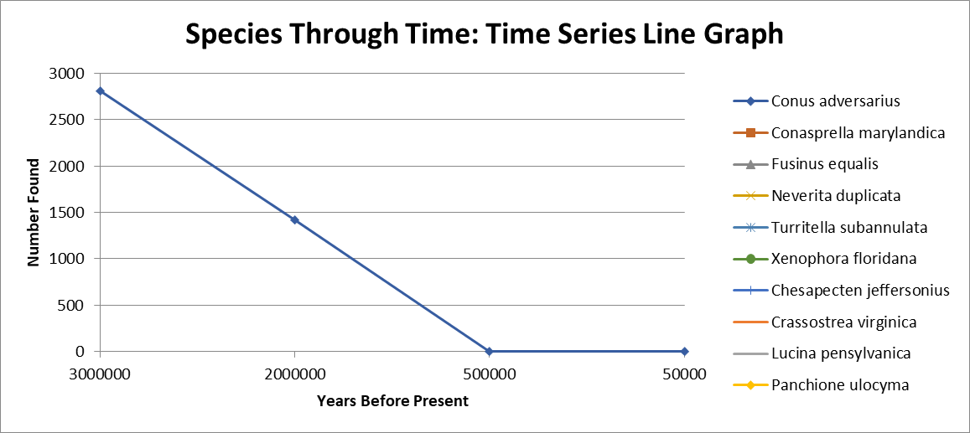
Name ______________________

Group Names ___________________________________________________________________________________________________

Current Evidence about Patterns in the Data  Things we know based on the current data sets: write both what we know and how the data shows it. | External Evidence  Things we know from other sources: books, other data, other science units, etc. Write both info and source. | Hypotheses and Speculation about Causes for Patterns  Ideas about what might have caused the changes observed in the data. | Open Questions and Missing Information  Things we don’t know or things we need to know to answer questions.

