Name Date

Marine Ecosystems and the Cretaceous Western Interior Seaway

Draw your favorite ecosystem! Make sure to include and label at least 1 producer and 2 consumers.

Ocean ecosystems are incredibly important to how the Earth functions, but they are different than land ecosystems in many ways. Today we’re going to be talking about how ocean ecosystems work with examples from the ancient past.

- Now think about the ocean. What might be the primary producers there? Are they the same as in ecosystems on land? What about primary consumers? Talk about it with the person next to you and be ready to share with the class.
The primary producers in marine ecosystems are phytoplankton, primary consumers are a variety of larval or juvenile fish and invertebrates.

The Western Interior Seaway was home to many animals that aren’t around today such as giant marine reptiles like mosasaurs and plesiosaurs, and large aquatic birds like Hesperornis. By learning about animals that aren’t around anymore, we can learn more about how the animals we see today work in their environments.

Ocean ecosystems have a lot of “niche partitioning” where animals that are the same shape do different things in their environment. A good example is how young fish eat different food than adult fish. Because they eat different food, there is more food to go around.

- Here are some animals that lived in the Western Interior Seaway. Their sizes are proportional (except the single-celled organism). Draw arrows from food to consumer.
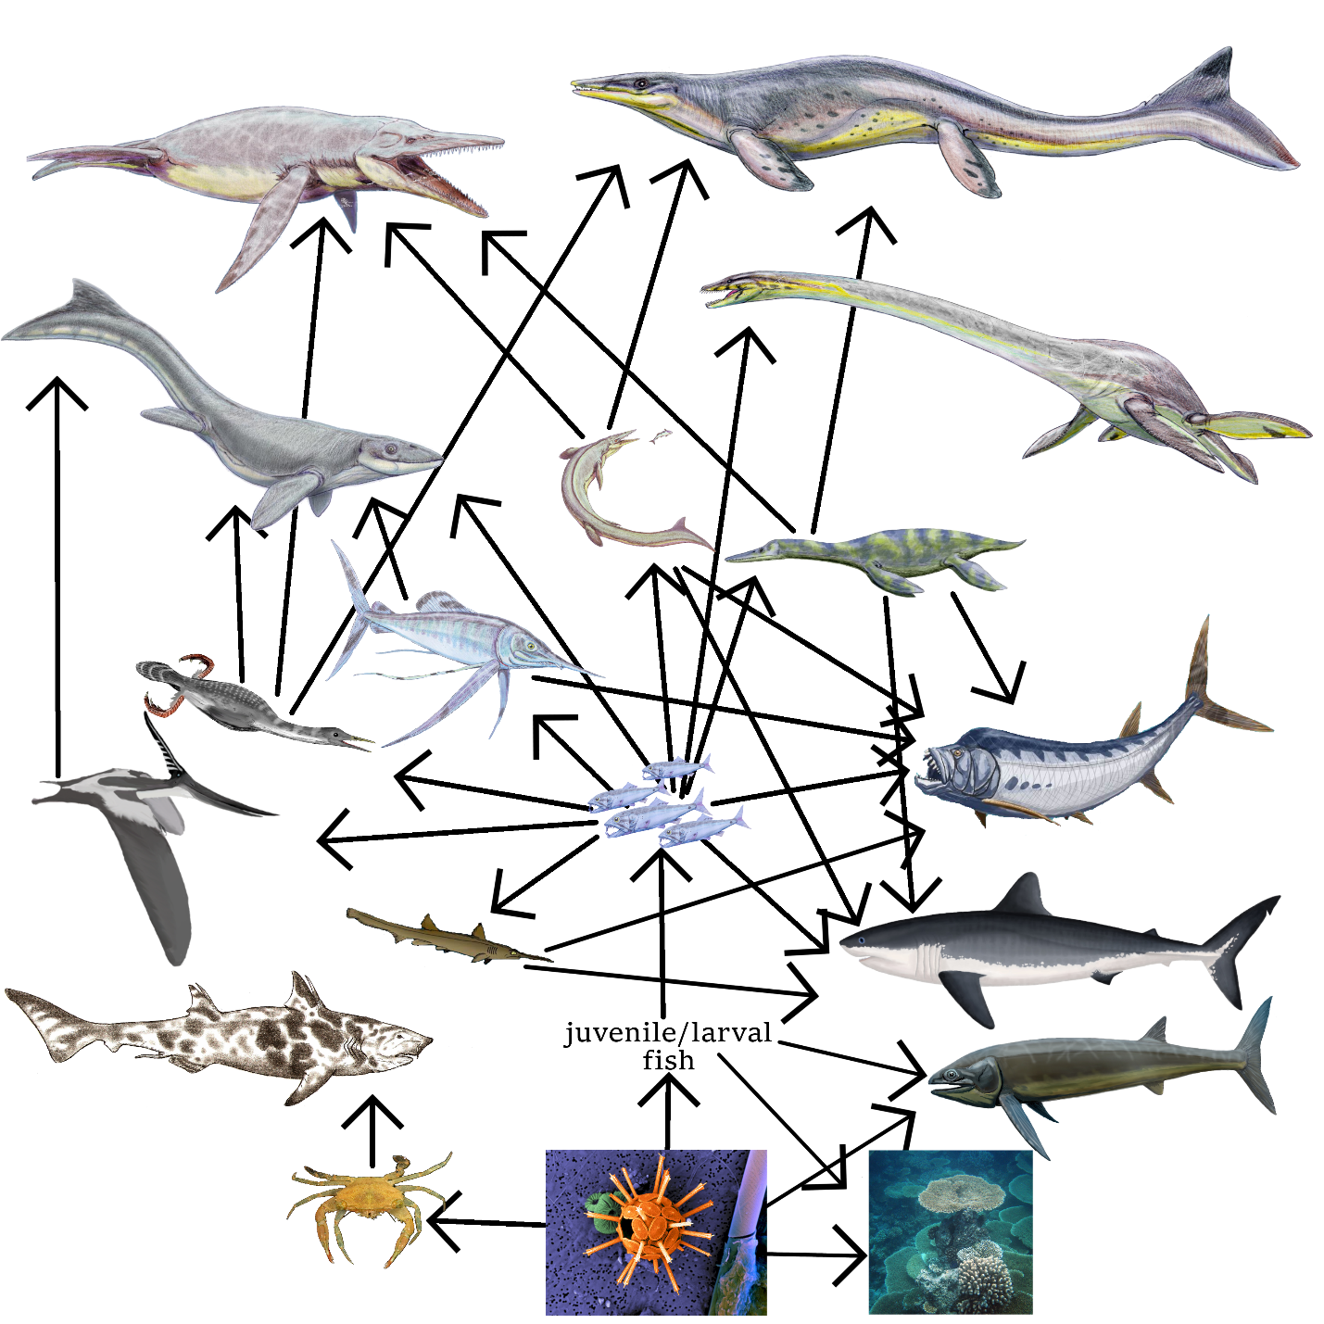

- Now compare your food web to one of your classmates’. How does yours look compared to theirs?

- What’s your favorite animal in this food web? Follow the energy from the bottom of the food web to it. How many steps does it take to get there?
For example; The Tylosaurus, the largest mosasaur located in the upper left corner of the web. The energy goes through at least five steps to get from the Sun to Tylosaurus.
Sun > single-celled organism > larval fish > medium fish > small mosasaur or small plesiosaur > Tylosaurus

- After going through this ocean food web, how is it different than food webs on land? How are they similar?

Marine food webs rely on phytoplankton as their primary producers, and support more kinds of predatory animals than terrestrial ecosystems do. They are similar in that their energy all comes from the Sun.

